Assignment 5: SQL Advanced Queries
Name: Your Name | Course: SQL | Submission: Assignment 5

Overview
This assignment builds on SQL skills by creating a Products table and writing targeted queries covering filtering, pattern matching, and range conditions to extract insights from product data.

1. Create and Populate Table
SQL Query:
CREATE TABLE Products (
ProductID INT PRIMARY KEY,
ProductName VARCHAR(50),
Category VARCHAR(50),
Price DECIMAL(10,2),
Stock INT
);
INSERT INTO Products (ProductID, ProductName, Category, Price, Stock) VALUES
(1, 'Laptop', 'Electronics', 800.00, 50),
(2, 'Smartphone','Electronics', 600.00, 30),
(3, 'Desk Chair','Furniture', 120.00, 100),
(4, 'Table', 'Furniture', 200.00, 20),
(5, 'Notebook', 'Stationery', 5.00, 500),
(6, 'Pen', 'Stationery', 2.00, 1000);
SELECT * FROM Products;
Output (screenshot_1):
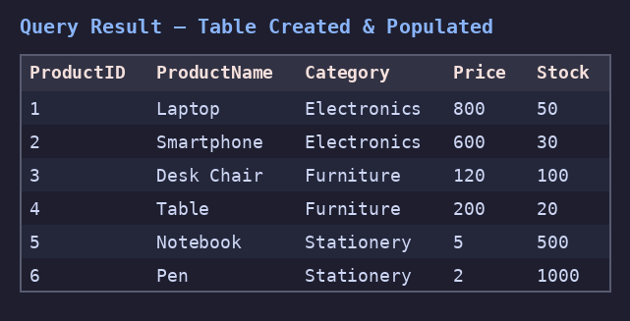

2. SQL Query Tasks

a) Electronics & Furniture
Retrieve products in categories Electronics or Furniture.
SQL Query:
SELECT * FROM Products
WHERE Category IN ('Electronics','Furniture');
Output (screenshot_2a):
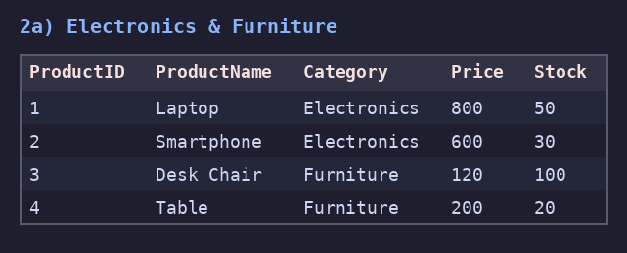

b) Price Range
Find products with price between 100 and 800.
SQL Query:
SELECT * FROM Products
WHERE Price BETWEEN 100 AND 800;
Output (screenshot_2b):
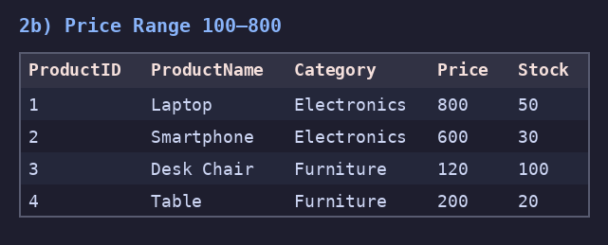

c) Stock Range
List products whose stock is between 50 and 500.
SQL Query:
SELECT * FROM Products
WHERE Stock BETWEEN 50 AND 500;
Output (screenshot_2c):
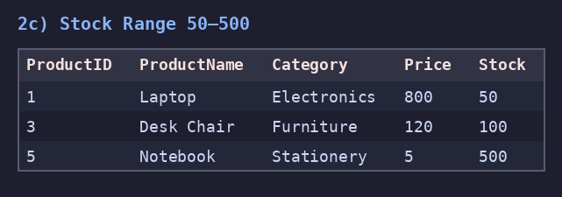

d) Name Contains 'Pen'
Select products with 'Pen' anywhere in the name.
SQL Query:
SELECT * FROM Products
WHERE ProductName LIKE '%Pen%';
Output (screenshot_2d):
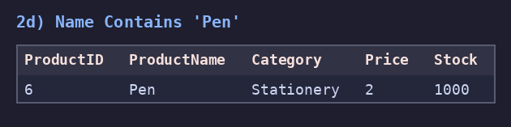

e) Name Starts With 'S'
Retrieve products whose names start with 'S'.
SQL Query:
SELECT * FROM Products
WHERE ProductName LIKE 'S%';
Output (screenshot_2e):
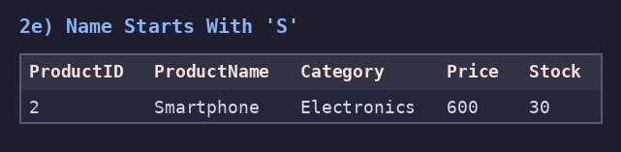

f) Category & Price
Products in Stationery or Furniture and price 100-300.
SQL Query:
SELECT * FROM Products
WHERE Category IN ('Stationery','Furniture')
AND Price BETWEEN 100 AND 300;
Output (screenshot_2f):
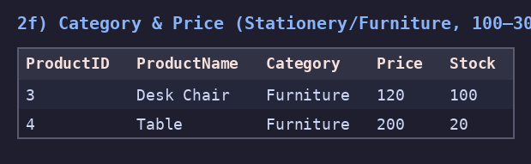

g) Low-Price 'o'
Products priced 1-10 and name contains 'o'.
SQL Query:
SELECT * FROM Products
WHERE Price BETWEEN 1 AND 10
AND ProductName LIKE '%o%';
Output (screenshot_2g):
